**PIZZA SALES SQL QUERIES**

A. KPI’s

1. Total Revenue:

SELECT SUM(total_price) AS Total_Revenue FROM pizza_sales;

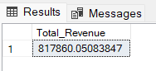

2. Average Order Value

SELECT (SUM(total_price) / COUNT(DISTINCT order_id)) AS Avg_order_Value FROM pizza_sales

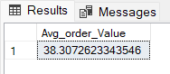

3. Total Pizzas Sold

SELECT SUM(quantity) AS Total_pizza_sold FROM pizza_sales

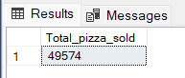

4. Total Orders

SELECT COUNT(DISTINCT order_id) AS Total_Orders FROM pizza_sales

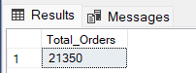

5. Average Pizzas Per Order

SELECT SUM(quantity) / COUNT(DISTINCT order_id) AS Avg_Pizzas_per_order

FROM pizza_sales

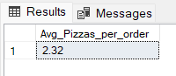

B. Daily Trend for Total Orders  
*Output:*

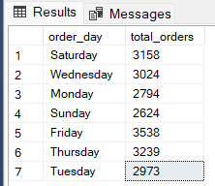

C. Monthly Trend for Orders

select monthname(STR_TO_DATE(order_date, '%d-%m-%Y')) as month_name, count(distinct order_id)as order_count from pizza_sales

group by month_name

order by order_count desc

*Output*

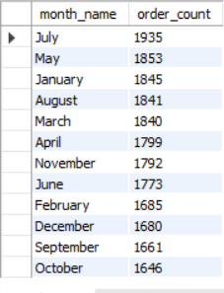

D. % of Sales by Pizza Category

SELECT

pizza_category,

MONTHNAME(STR_TO_DATE(order_date, '%d-%m-%Y')) AS month_name,

SUM(total_price) as total_sales,

(SUM(total_price) / (SELECT SUM(total_price) FROM pizza_sales WHERE MONTH(STR_TO_DATE(order_date, '%d-%m-%Y')) = 1)) * 100 AS percentage_of_sales

FROM pizza_sales

WHERE MONTH(STR_TO_DATE(order_date, '%d-%m-%Y')) = 1

GROUP BY pizza_category, month_name

ORDER BY percentage_of_sales DESC;

*Output*

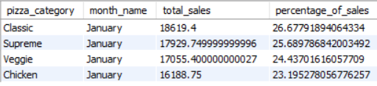

E. % of Sales by Pizza Size

SELECT

pizza_size,

SUM(total_price) as total_sales,

(SUM(total_price) / (SELECT SUM(total_price) FROM pizza_sales)) * 100 AS percentage_of_sales

FROM pizza_sales

GROUP BY pizza_size

order by percentage_of_sales desc

*Output*

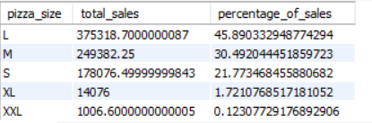

F. Total Pizzas Sold by Pizza Category

SELECT

pizza_category,

MONTHNAME(STR_TO_DATE(order_date, '%d-%m-%Y')) AS month_name,

SUM(quantity) as total_quantity

FROM pizza_sales

WHERE MONTH(STR_TO_DATE(order_date, '%d-%m-%Y')) = 2

GROUP BY pizza_category, month_name

ORDER BY total_quantity DESC;

*Output*

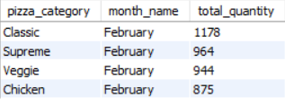

G. Top 5 Pizzas by Revenue

SELECT pizza_name, SUM(total_price) AS Total_Revenue

FROM pizza_sales

GROUP BY pizza_name

ORDER BY Total_Revenue DESC

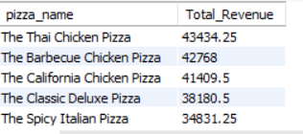

H. Bottom 5 Pizzas by Revenue

SELECT pizza_name, SUM(total_price) AS Total_Revenue

FROM pizza_sales

GROUP BY pizza_name

ORDER BY Total_Revenue ASC

LIMIT 5;

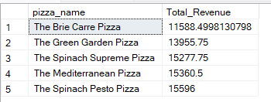

I. Top 5 Pizzas by Quantity

SELECT pizza_name, SUM(quantity) AS Total_Pizza_Sold

FROM pizza_sales

GROUP BY pizza_name

ORDER BY Total_Pizza_Sold DESC

limit 5

*Output*

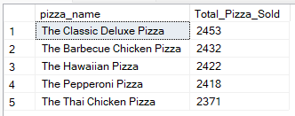

J. Bottom 5 Pizzas by Quantity

SELECT pizza_name, SUM(quantity) AS Total_Pizza_Sold

FROM pizza_sales

GROUP BY pizza_name

ORDER BY Total_Pizza_Sold asc

limit 5

*Output*

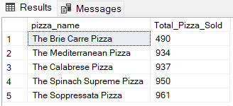

K. Top 5 Pizzas by Total Orders

SELECT pizza_name, COUNT(DISTINCT order_id) AS Total_Orders

FROM pizza_sales

GROUP BY pizza_name

ORDER BY Total_Orders DESC

limit 5

L. Borrom 5 Pizzas by Total Orders

SELECT Top 5 pizza_name, COUNT(DISTINCT order_id) AS Total_Orders

FROM pizza_sales

GROUP BY pizza_name

ORDER BY Total_Orders ASC

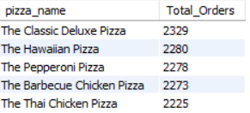

*NOTE*

If you want to apply the pizza_category or pizza_size filters to the above queries you can use WHERE clause. Follow some of below examples

SELECT Top 5 pizza_name, COUNT(DISTINCT order_id) AS Total_Orders

FROM pizza_sales

WHERE pizza_category = 'Classic'

GROUP BY pizza_name

ORDER BY Total_Orders ASC